Hands on Object Oriented Programming with Java
- Inheritance and Polymorphism
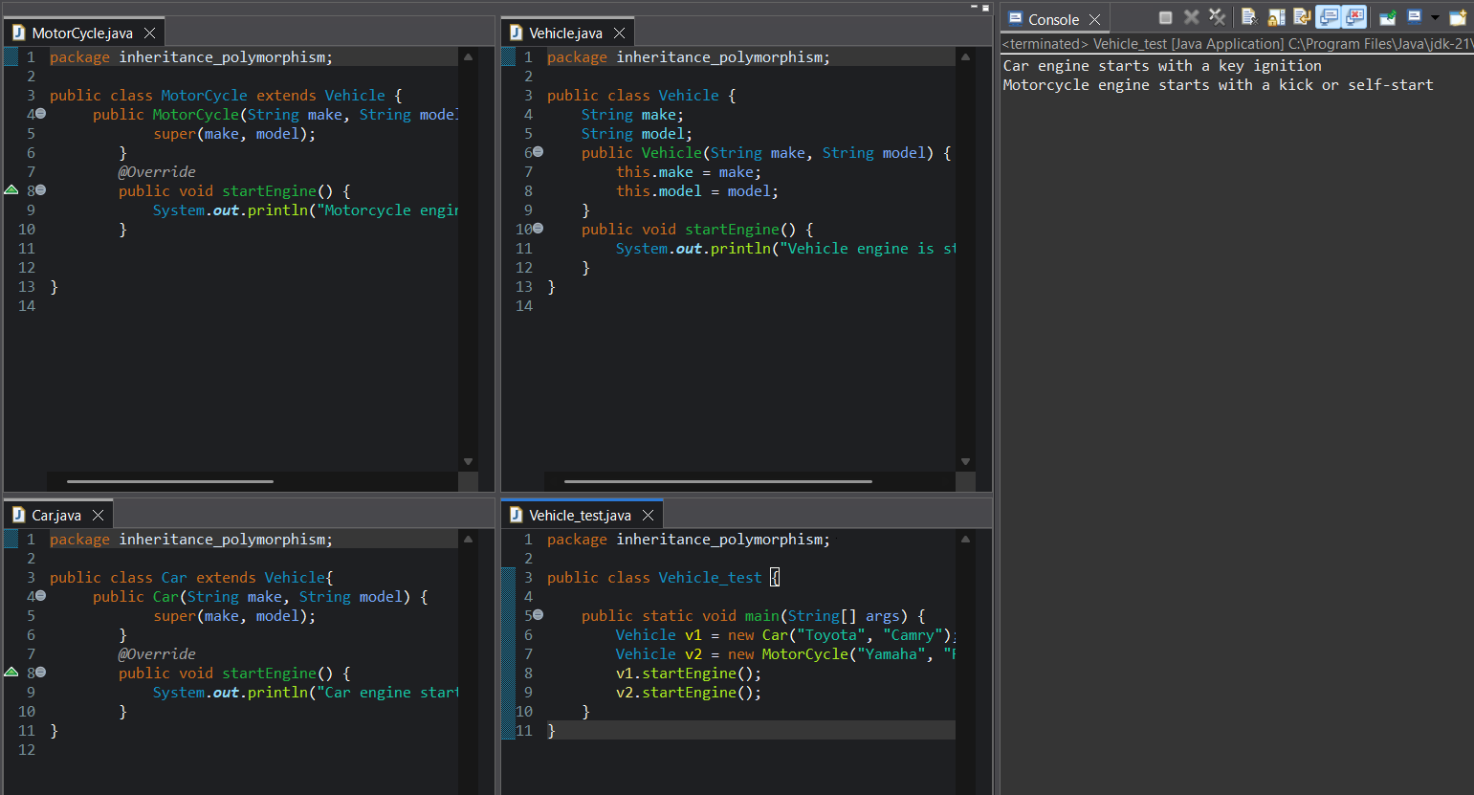
- Abstraction and Interfaces
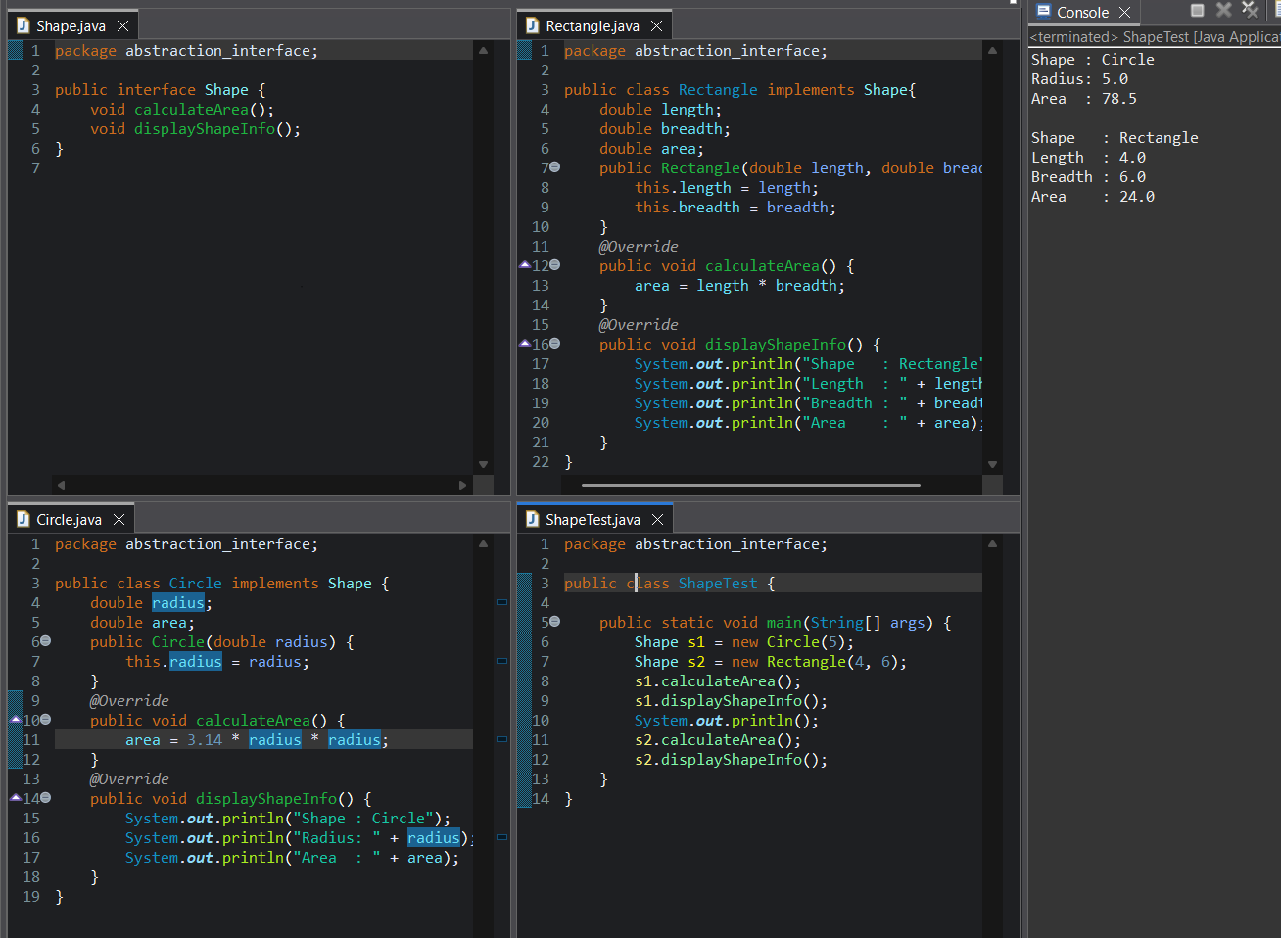

- Abstract Classes and Polymorphism
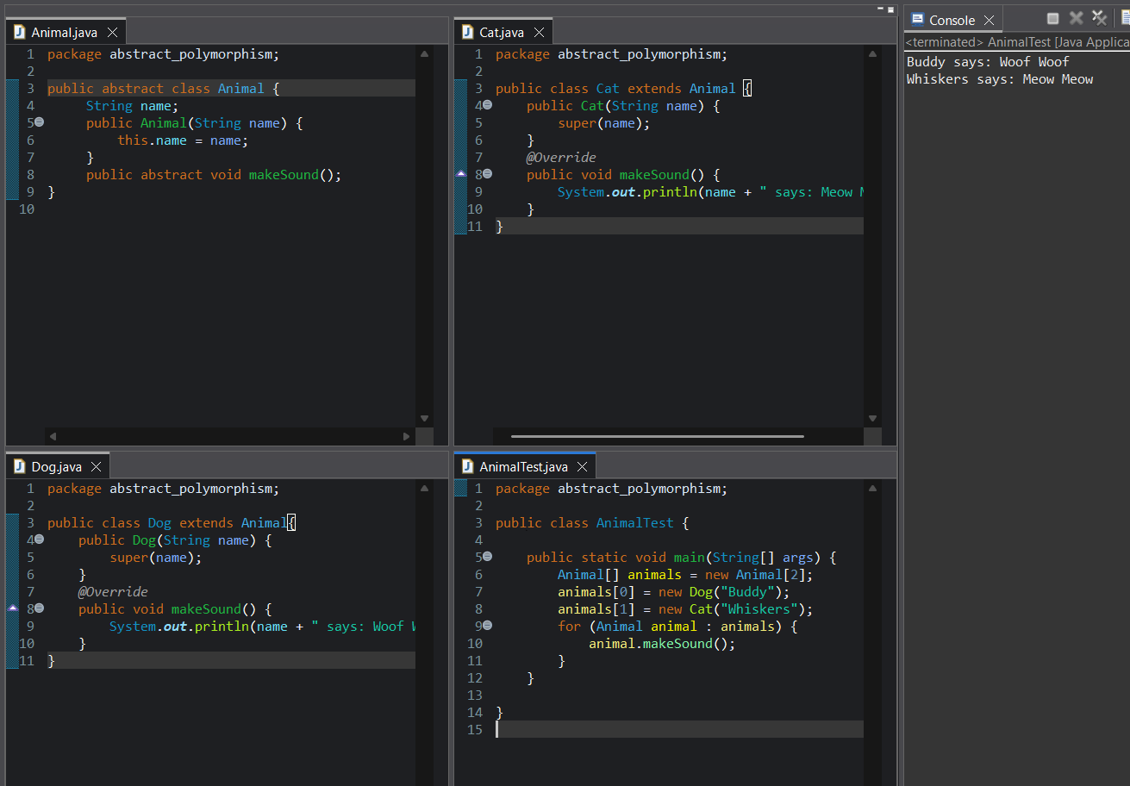
- Encapsulation and Interfaces
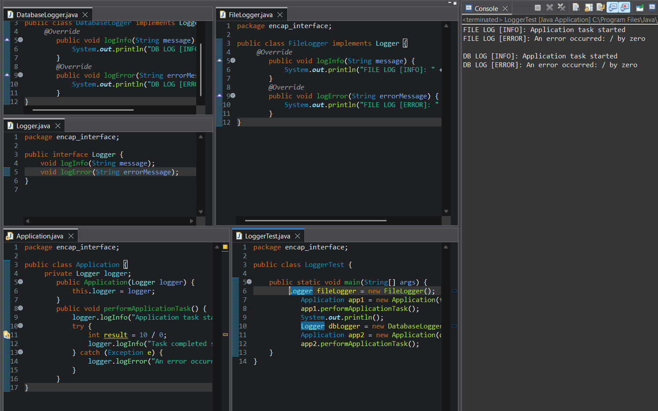

- Exception Handling
